Lung Cancer Prediction Model using Machine Learning Models

|  |  |
| --- | --- |
| Manish Kumar Das  Department of Computer Science  Lovely Professional University  Jalandhar, India  https://orcid.org/0009-0006-7029-4958 | Ved Prakash Chaubey  UpGrad Campus, UpGrad Education Private Limited Bangalore, Karnataka, India,  ORCID-0000-0003-3049-8316  Email id: - vedeprakesh05@gmail.com |

*Abstract*

*Lung cancer continues to be a major public health issue. The improvement of patient outcomes is contingent upon early identification. To improve lung cancer diagnosis, this study investigates the potential of machine learning (ML) models in survey data analysis. Our goal is to create and assess machine learning models with a thorough survey instrument that records demographics, medical history, and pertinent symptoms. To find patterns and correlations that could indicate a person's risk of developing lung cancer, the models will be trained and validated on a sizable dataset. We will evaluate how well different machine learning algorithms perform in terms of lung cancer detection, considering factors like sensitivity, specificity, and accuracy. Based on survey data and machine learning, this work may aid in the creation of effective, non-invasive, and reasonably priced lung cancer screening instruments.*

**Keywords**: Convolutional Neural Network, Machine Learning, Web Application, Teras, TensorFlow, Supervised Learning, Unsupervised Learning, Semi-Supervised Learning.

I. INTRODUCTION

While lung cancer remains world's foremost cause of death outcomes for patients are dramatically improved with early detection. Machine learning (ML) and artificial intelligence (AI) are prominent tools in this endeavour, fundamentally altering the approach towards lung cancer diagnosis. The objective of this project is to explore crafting a machine learning model. This model will be able to analyse medical images. These images can include CT scans or chest X-rays. The aim is to identify potential cases of lung cancer. Utilising the power of ML algorithms our objectives are as follows:

* Enhance Accuracy: Algorithm we develop seeks to identify lung cancer with a higher degree of precision than traditional techniques. This could reduce the number of diagnoses that are missed.
* Promote Early Detection: Timely detection is crucial for effective treatment. The software will be trained to detect subtle signs of early-stage lung cancer.
* Support for Radiologists: We envision the model as an essential tool for radiologists. It will highlight areas of concern, simplifying their workflow.

The potential for research to monumentally impact lung cancer diagnosis is high. It accomplishes this by assisting in early detection while enhancing overall accuracy. ML models can contribute in a profound way to improved patient outcomes. Their contribution could potentially save lives. This introduction readies the ground for your project. It highlights the significance of lung cancer detection and the role of AI and ML. The potential benefits of your model are also underscored. Depending on the intricacies of your unique project you may wish to ponder on including these extra points:

You may elect to briefly mention the type of ML model you're set to use. For instance, a model employing deep learning with convolutional neural networks may be used. You could choose to highlight the medical imagery your model will be trained on. It could be X-ray or CT scan images.

**II. LITERATURE REVIEW**

* The Potential of ML:

1. Studies have explored various ML algorithms for lung cancer prediction, including logistic regression, support vector machines (SVMs), decision trees, and artificial neural networks (ANNs).
2. Research suggests that ML models can achieve high accuracy in lung cancer prediction using data from patient demographics, medical history, and imaging scans (like CT scans).
3. Even with patient data like symptoms and questionnaires, ML models have shown promise in differentiating between high-risk and low-risk individuals, particularly for never-smokers.

* Focus on Data and Techniques:

1. A key aspect of ML-based lung cancer prediction is the data used for training and testing the models.
2. Studies emphasize the importance of high-quality, comprehensive datasets to ensure model generalizability.
3. Deep learning techniques, particularly convolutional neural networks (CNNs), have emerged as powerful tools for analysing medical images and identifying lung cancer nodules in CT scans.

* Challenges and Considerations:

1. Despite the potential, ML models for lung cancer prediction are not without limitations. Data imbalance and the "black box" nature of some algorithms can pose challenges.
2. The interpretability of ML models is crucial for gaining trust from medical professionals. Understanding how the model arrives at its predictions is essential for real-world applications.

**III. HYPOTHESIS**

1. Hypothesis 1 (Emphasizing Improved Accuracy): Comparatively a machine learning model, trained on sizable and varied dataset can surpass traditional diagnostic techniques. These conventional techniques include radiologists' visual inspection of chest X-rays or CT scans. The model can achieve greater accuracy in identifying lung cancer. The theory points to the greater overall accuracy of machine learning models. Machine learning models are potentially superior to current techniques.

2. Hypothesis 2 (Early Detection): A machine learning model could be custom-built. It's tailored to recognize subtle details in chest X-rays. Such details indicate early stages of lung cancer. With this, treatment-effectiveness might be maximized. Traditional methods may be outperformed by this model. This hypothesis revolves around early lung cancer detection by machine learning algorithms. It suggests improved patient outcomes as a potential result.

# IV. RESEARCH GAPS

Lung cancer detection research using machine learning holds immense promise, but there are still significant gaps to address. Here are some key research gaps:

**Data limitations:**

* **Data Quality and Generalizability:**

Much research relies on datasets from specific hospitals, potentially limiting generalizability to other populations.

Data quality issues like missing information or inconsistencies can affect model performance.

* **Class Imbalance:**

Lung cancer cases are often rare compared to healthy controls. Unaddressed imbalance can lead to models biased towards the majority class.

* **Model Explain-ability and Trust:**

**Black Box Problem:**

Deep learning models, while powerful, can be difficult to interpret. Doctors need to understand the rationale behind a model's prediction for trust and potential refinement.

* **Clinical Integration Challenges:**

1. **High False Positive Rates:**

Many models struggle with a high rate of false positives, leading to unnecessary biopsies and patient anxiety.

1. **Integration into Workflow:**

Seamless integration of AI models into existing clinical workflows for radiologists is crucial for real-world adoption.

* **Other Promising, Yet Underdeveloped Areas:**

1. **Early Detection Biomarkers:**
2. Research on incorporating blood tests or other non-invasive methods to identify early-stage lung cancer alongside imaging data is needed.
3. **AI-assisted Diagnosis Tools:**
4. Developing AI tools that can not only detect nodules but also classify their malignancy would be a major leap forward.
5. **Personalized Medicine Approaches:**
6. Tailoring models to individual patient characteristics (e.g., smoking history) for improved risk prediction.

**V. METHODOLOGY**

**1.Data Acquisition**:

* Type of Data: Excel Sheet with various Symptoms and their Alcohol and Smoking Habits which corresponds to their chances to acquire the said disease.

2. Data Preprocessing:

* Data Cleaning: Handle missing values, null values, and inconsistencies.
* Normalization/Standardization: Ensure data features are on a similar scale.
* Data Augmentation (Optional): Artificially increase dataset size with rotations, flips, etc. (improves model generalizability).

3. Feature Engineering (Optional for Deep Learning):

* Manual feature extraction (e.g., size, shape, intensity of dataset).
* Dimensionality reduction techniques if feature set is high-dimensional.

4. Model Selection and Training:

* Deep Learning Models: Convolutional Neural Networks (CNNs) are dominant due to their ability to learn features directly from images. (e.g., VGG16, ResNet)
* Traditional Machine Learning Models: Can be used for simpler tasks or with limited data. (e.g., Support Vector Machines (SVM), Random Forests)
* Model Training: Split data into training, validation, and testing sets. Train the model on the training set, fine-tune hyper-parameters using the validation set, and evaluate final performance on the testing set.

5. Model Evaluation:

1. Metrics: Accuracy, Sensitivity (true positive rate), Specificity (true negative rate), Precision (positive predictive value), Area Under the ROC Curve (AUC).
2. Visualization Techniques: Utilize techniques like confusion matrices to understand model performance across different classes (cancerous vs. non-cancerous).

6. Model Deployment and Refinement:

1. Integrate the model into a clinical workflow for radiologist support.
2. Continuously monitor model performance and retrain with new data for improved accuracy over time.
3. Additional Considerations:

* Class Imbalance: If cancerous cases are rare, address class imbalance by oversampling minority class or using appropriate cost functions during training.
* Interpretability: Deep learning models can be "black boxes." Consider techniques like LIME for explaining model predictions to medical professionals.
* Ethical Considerations: Ensure data privacy and anonymization.
* Regulatory Approval: For clinical deployment, navigate regulatory requirements for medical devices.

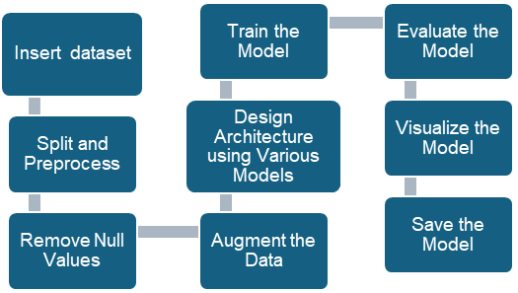

Lung cancer detection research using machine learning holds immense promise, but there are still significant gaps to address. Here are some key research gaps:

**Data limitations:**

* **Data Quality and Generalizability:**

Much research relies on datasets from specific hospitals, potentially limiting generalizability to other populations.

Data quality issues like missing information or inconsistencies can affect model performance.

* **Class Imbalance:**

Lung cancer cases are often rare compared to healthy controls. Unaddressed imbalance can lead to models biased towards the majority class.

**Model Explainability and Trust:**

* **Black Box Problem:**

Deep learning models, while powerful, can be difficult to interpret. Doctors need to understand the rationale behind a model's prediction for trust and potential refinement.

**Clinical Integration Challenges:**

* **High False Positive Rates:**

Many models struggle with a high rate of false positives, leading to unnecessary biopsies and patient anxiety.

* **Integration into Workflow:**

Seamless integration of AI models into existing clinical workflows for radiologists is crucial for real-world adoption.

**Other Promising, Yet Underdeveloped Areas:**

* **Early Detection Biomarkers:**

Research on incorporating blood tests or other non-invasive methods to identify early-stage lung cancer alongside imaging data is needed.

* **AI-assisted Diagnosis Tools:**

Developing AI tools that can not only detect nodules but also classify their malignancy would be a major leap forward.

* **Personalized Medicine Approaches:**

Tailoring models to individual patient characteristics (e.g., smoking history) for improved risk prediction.

**VI. MACHINE LEARNING MODELS USED**

* **Logistic Regression:**

Logistic regression is a workhorse in the world of machine learning, particularly useful for **classifying things into two categories**. Imagine you want to predict whether an email is spam or not, or if a patient has a certain disease based on symptoms. This is where logistic regression shines. Unlike its cousin linear regression, which predicts continuous values, logistic regression deals with binary outcomes – yes/no, 0/1, positive/negative. But how does it make the call?

Logistic regression builds a mathematical model using a sigmoid function, which looks like an S-shaped curve. This function takes a bunch of input features (like email content or patient data) and transforms them into a probability between 0 and 1. A value closer to 1 suggests a high chance of belonging to one category (e.g., spam), while a value closer to 0 indicates the other (not spam).

The key is training the model with existing data where the outcome is already known. This allows logistic regression to learn the relationships between features and the desired outcome, enabling it to make predictions on new data. Overall, logistic regression is a powerful tool for classification tasks, offering a clear probability estimate for each prediction. Its ease of interpretation and implementation makes it a popular choice for various applications in machine learning.

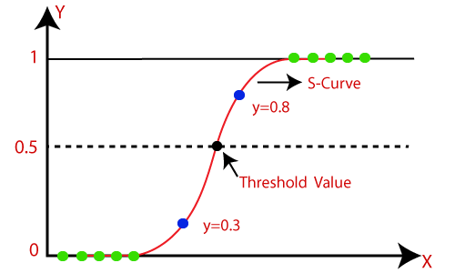

* **Decision Tree Algorithm:**

Imagine a flowchart that helps you make decisions based on a series of questions. That's the essence of a decision tree algorithm, a powerful tool in machine learning.

This supervised learning method works by building a tree structure where:

* **Internal nodes** represent questions based on features of your data (like weather for predicting picnics).
* **Branches** represent the possible answers (sunny/rainy).
* **Leaf nodes** represent the outcome (picnic possible/cancelled).

The algorithm trains itself by recursively splitting the data into subsets based on the most informative feature at each step. It aims to minimize randomness (impurity) in the resulting subsets, leading to more accurate predictions.

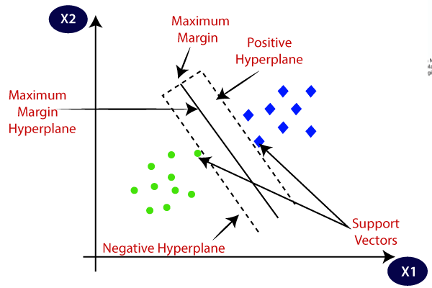

Decision trees are versatile. They can handle both classification (spam/not spam) and regression (predicting house prices) tasks. They're also interpretable, allowing you to understand the logic behind their predictions.

However, decision trees can become overly complex and prone to overfitting if not carefully controlled. Nevertheless, they remain a fundamental algorithm for various machine learning applications.

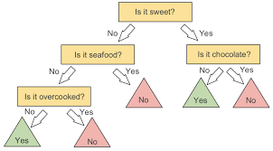

* **SUPPORT VECTOR MACHINE ALGORITHM:**

Support Vector Machines (SVMs) are another powerful supervised learning technique, tackling both **classification and regression problems**. Imagine you have data points representing apples and oranges, and you want to draw a clear boundary to separate them. SVMs excel at this kind of task.

Instead of a simple line like logistic regression, SVMs find a hyperplane (a plane in higher dimensions) that best divides the data points into their respective classes. But SVMs are picky – they aim for the widest possible margin between the hyperplane and the closest data points from each class. These closest data points are called support vectors, and they essentially define the decision boundary.

The wider the margin, the more robust the SVM's classification is to unseen data. This makes SVMs effective even with complex datasets. However, SVMs can struggle with high-dimensional data or data with a lot of noise.

Another advantage of SVMs is their focus on the data points that matter most – the support vectors. This allows for a potentially more efficient model compared to other algorithms. Overall, SVMs are a versatile tool for classification tasks, offering good performance and interpretability in many scenarios.

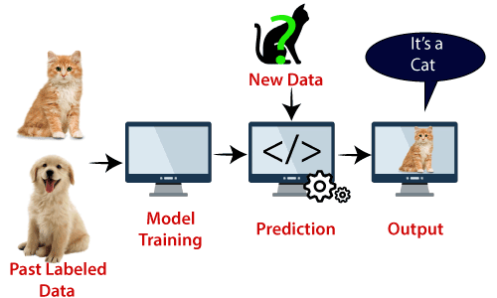

* **Naïve Bayes Algorithm:**

Naive Bayes, another champion in the machine learning classification arena, tackles problems with multiple categories, not just two. Imagine sorting emails into spam, important, or promotional folders. Here's where Naive Bayes comes in.

Despite its "naive" name, it's surprisingly effective. Naive Bayes is based on Bayes' theorem, a powerful tool for calculating probabilities. The "naive" part comes from its assumption that features, like words in an email, are independent of each other given the category (spam/important). For an email, Naive Bayes calculates the probability of it being spam considering each word individually. Then, it multiplies these probabilities to get a final spam probability score. The same is done for other categories (important, promotional). The email is assigned to the category with the highest score.

Training involves feeding Naive Bayes a bunch of pre-categorized emails. This lets it learn the probabilities of words appearing in each category. With this knowledge, it can analyse new emails and classify them efficiently. Naive Bayes' simplicity and speed make it a popular choice for text classification, spam filtering, and sentiment analysis. However, its independence assumption isn't always perfect, and it might struggle with complex relationships between features.

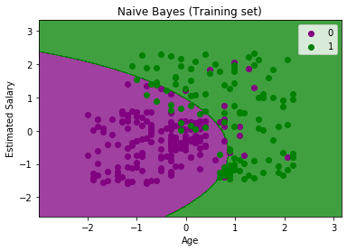

**In the above output we can see that the Naïve Bayes classifier has segregated the data points with the fine boundary. It is Gaussian curve as we have used Gaussian classifier in our code.**

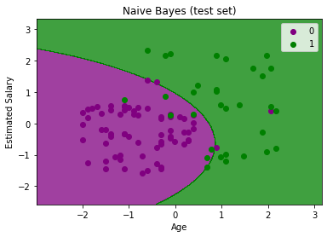

**The above output is final output for test set data. As we can see the classifier has created a Gaussian curve to divide the "purchased" and "not purchased" variables. There are some wrong predictions which we have calculated in Confusion matrix.**

* **K-Nearest Neighbour (KNN):**

K-Nearest Neighbours (KNN) is a straightforward and versatile algorithm in machine learning, used for both classification and regression tasks. Imagine you're at a party and want to know someone's interests. KNN assumes people close to each other (your neighbours) likely share similar interests. So, to predict someone's preferences, KNN identifies the closest k people (based on a chosen distance metric) and examines their interests.

* Training: KNN doesn't require complex training. It simply stores all existing data points.
* Prediction: When a new data point arrives, KNN calculates the distance to all stored points. It then identifies the k closest neighbours (k is a user-defined parameter).
* Classification: For classification, KNN predicts the class (category) that's most frequent among the k neighbours. Imagine your k closest partygoers are mostly into sports, so KNN predicts you'll enjoy sports too.
* Regression: For regression, KNN predicts the value for the new data point by averaging the values of its k neighbours.

KNN's strength lies in its simplicity and ability to handle various data types. However, it requires storing all training data, which can be memory-intensive for large datasets. Additionally, choosing the optimal value for k is crucial for accurate predictions.

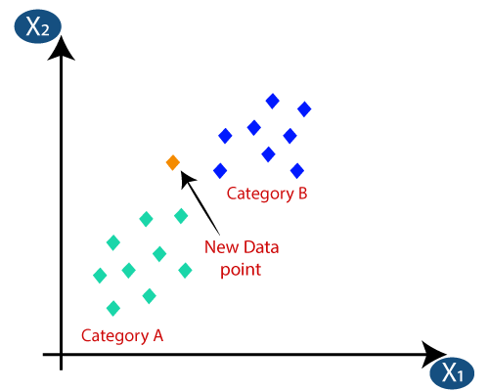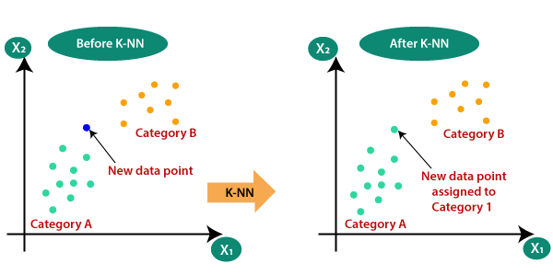

* **Random Forest Algorithm:**

Random forest is a powerful machine learning algorithm known for its versatility and accuracy. Unlike some algorithms stuck to a single approach, random forest leverages the wisdom of crowds – by combining multiple decision trees.

Imagine a forest – each tree is a simple decision tree, making predictions based on a series of yes/no questions. But here's the twist: randomness is injected in two ways. First, when building each tree, a random subset of features from the data is chosen. This prevents trees from becoming too similar and overfitting the data. Second, random data points are drawn from the training set with replacement (meaning some can be chosen multiple times).

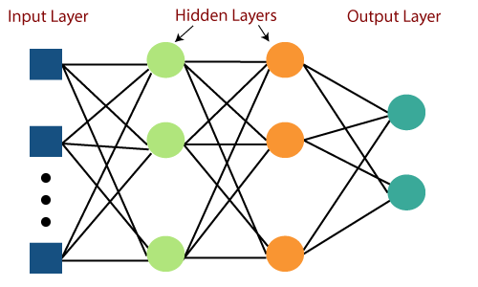

So how does the forest decide? Each tree votes for a particular outcome, and in classification tasks, the majority vote wins. For regression problems, the average prediction across the trees is used. This ensemble approach reduces the risk of any single tree making a poor decision. Random forest's strengths lie in its accuracy, ability to handle various data types, and resistance to overfitting. It's a popular choice for both classification and regression tasks, making it a valuable tool in the machine learning toolbox.

* **Gradient Boost Algorithm:**

Gradient boosting is a super smart machine learning technique that can do both predicting numbers and classifying things well. Just imagine it like a team, where everyone learns from each other’s mistakes.

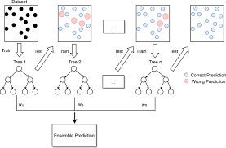

It all starts with a basic prediction model, usually a simple decision tree. Teamwork is the key to success: We create a new model that fixes the mistakes of the first one, making it even better. We keep going back and forth, making new models, and focusing on the mistakes, and then putting them all together. Gradient boosting keeps getting better by adding more focused learners. It’s like a team that’s always learning and improving, getting better with each challenge. way of saying: This method makes gradient boosting good at dealing with complicated data and helps it not overfit.

* **Multi-layer Perceptron:**

The Multilayer Perceptron (MLP) is a powerful neural network used to solve more complex problems unlike Logistic Regression. Imagine a layered network of interconnected processing units, like a brain. This is the core of an MLP. MLP consists of an input layer, an output layer, and hidden layers in between. Each layer contains artificial neurons that process data, flowing forward through the network unlike Logistic Regression. Within each neuron, weighted connections influence input data. These weights act like dials, determining each input's impact. Activation functions add non-linearity, enabling MLP to uncover complex patterns in data that Logistic Regression cannot.

* **Cross- Validation:**

In machine learning, when training models to make accurate predictions, the ability of the model to perform well on previously unseen data is essential. To ensure this, cross-validation is a technique that helps avoid overfitting. Overfitting occurs when a model performs well on the specific data it was trained on but struggles to predict on new data. Cross-validation involves:

1. Data Division: Splitting the available data into multiple sets called "folds" (commonly 5 or 10).

2. Train-Test Split: In each iteration, one-fold is designated as the test set (validation set), while the remaining folds are used for training.

3. Model Training: Training the model using the training data.

4. Performance Evaluation: Using the validation set to test the performance of the trained model.

5. Repetition: Repeating steps 2-4 for all folds. Cross-validation allows the model to be tested on different sets of unseen data, providing a better understanding of its accuracy and generalization ability.

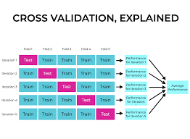

* **K-Fold Cross-Validation:**

K-fold cross-validation is a method for assessing the performance of a machine learning model on new, unseen data. It addresses the problem of a model possibly memorizing the specific training dataset (overfitting) instead of generalizing well to different data.

How it works:

* Data division: Split the dataset into k roughly equal subsets, like dividing a cake into k slices. Common values for k are 5 or 10.
* Train-test split: Repeat the following k times:
* Use k-1 folds for training the model, as if practicing baking with most of the cake. Use the remaining fold as the test set, like a slice given to a friend, to evaluate the model's ability to perform on unseen data.
* Iteration and learning: Repeat the process multiple times. This allows the model to learn from different combinations of training and test data, leading to a better understanding of its generalization capabilities.

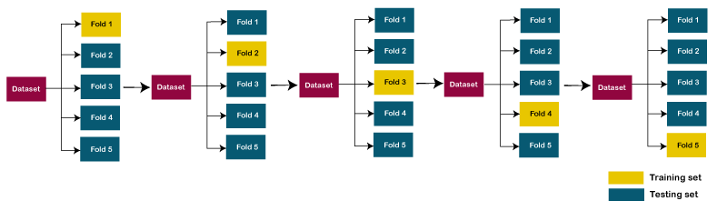

* **Stratified k-fold cross-validation:**

Stratified cross-validation tackles a common pitfall in regular k-fold cross-validation for classification problems with imbalanced classes. Imagine you're training a model to identify cat breeds in images, but most pictures are of housecats. Regular k-fold splits might end up with test sets lacking rare breeds like Bengals.

Stratified cross-validation fixes this by ensuring each fold in the k-folds (usually 5 or 10) has a similar proportion of classes as the entire dataset. This is achieved through stratified sampling. Here's how it works:

* **Shuffle the data:** Randomize the order of data points.
* **Divide by class:** Split the data based on the target variable (e.g., cat breed) into separate groups.
* **Fold by proportions:** From each class group, create folds (sub-groups) that maintain the class proportions of the whole dataset.
* **Repeat:** Perform steps 1-3 for k times to create k folds.

During k-fold evaluation, each fold becomes the test set in turn, with the remaining folds combined for training. This ensures all classes get a fair shot at being in the test set, leading to a more robust evaluation of your machine learning model's performance, especially for imbalanced classification tasks.

**VII. LIBRARIES USED:**

The useful libraries used for flower recognition models using Convolutional Neural Networks (CNN) include:

1. **TensorFlow**: A powerful library for building and training neural networks, providing a range of functions to achieve complex functionalities with minimal code.

2**. Keras**: A high-level neural networks API that simplifies the process of building deep learning models, acting as a wrapper for libraries like TensorFlow.

3**. NumPy**: A fundamental package for scientific computing in Python, essential for handling large computations and mathematical operations efficiently.

4. **Matplotlib**: A plotting library used to create visualizations, aiding in data analysis and model performance evaluation.

5**. OpenCV**: Focused on image processing and handling, crucial for tasks like image resizing and manipulation in flower recognition projects.

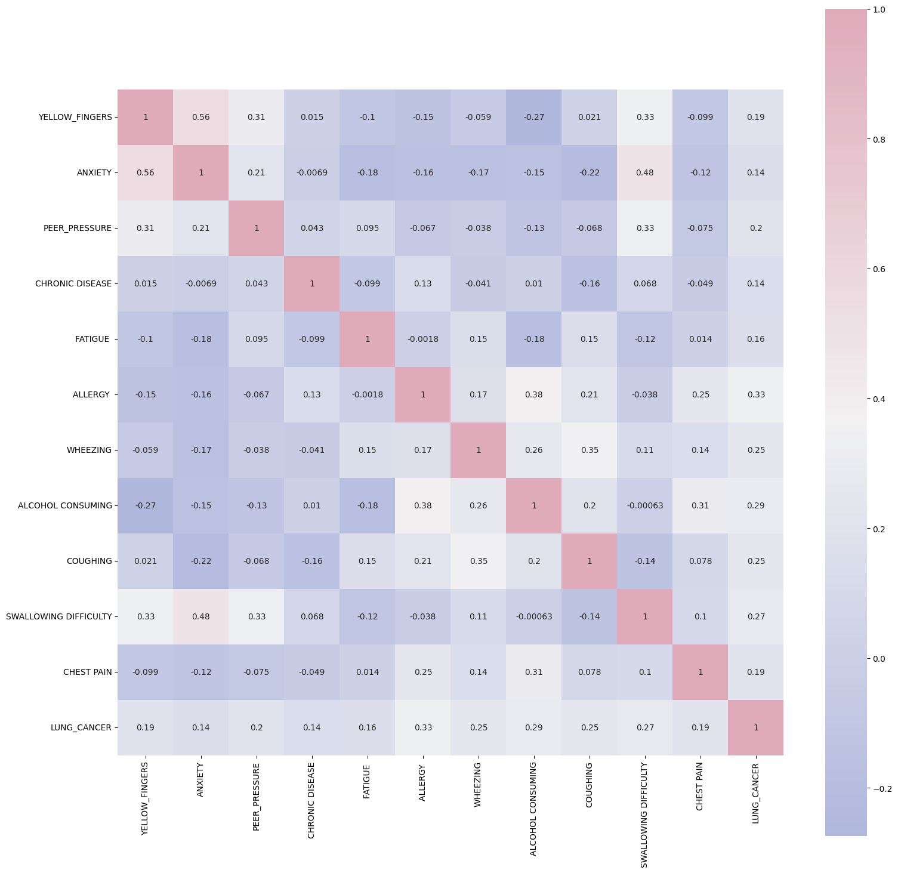

6. **Scikit-learn**: A machine learning framework that offers tools for building and evaluating various machine learning models, including image classification tasks.

7. **Pandas**: A data manipulation and analysis tool used for handling tabular data, which can be beneficial for preprocessing datasets in flower recognition projects.

8**. Seaborn**: A Python visualization library based on Matplotlib, providing a high-level interface for creating attractive statistical graphics.

**VIII. FIGURES**

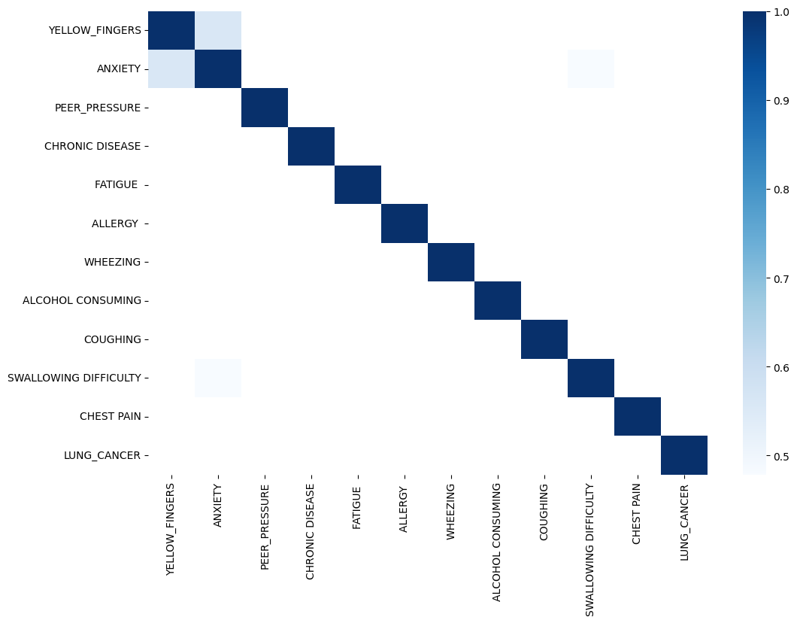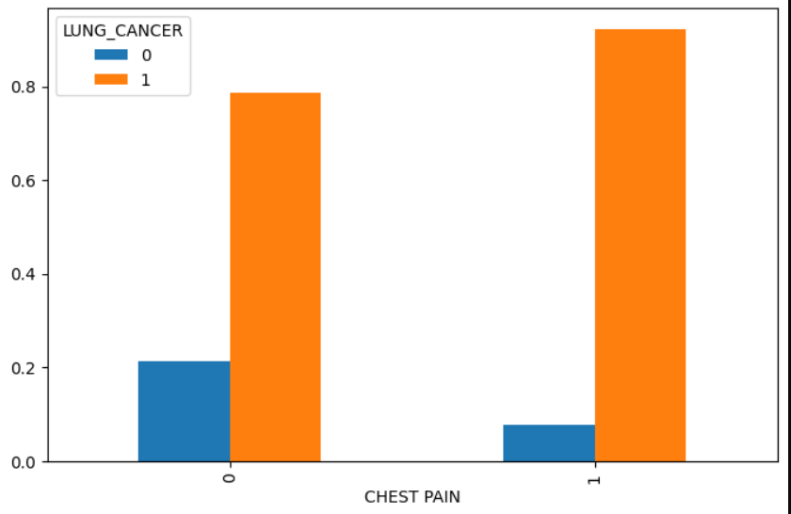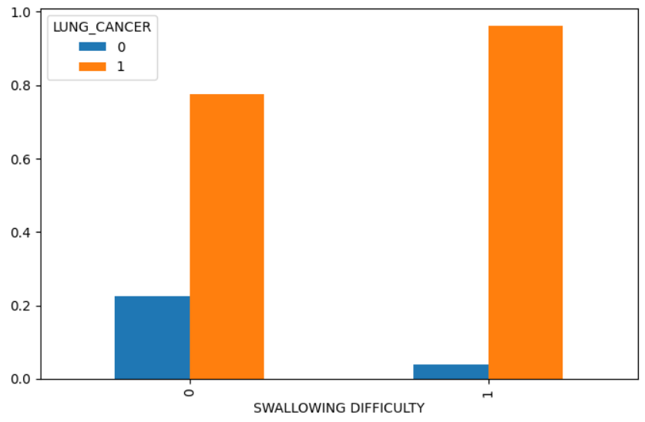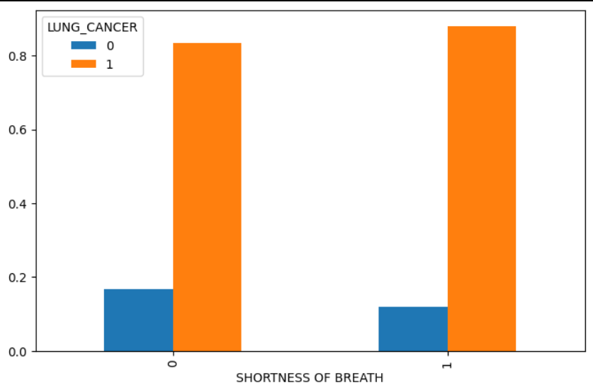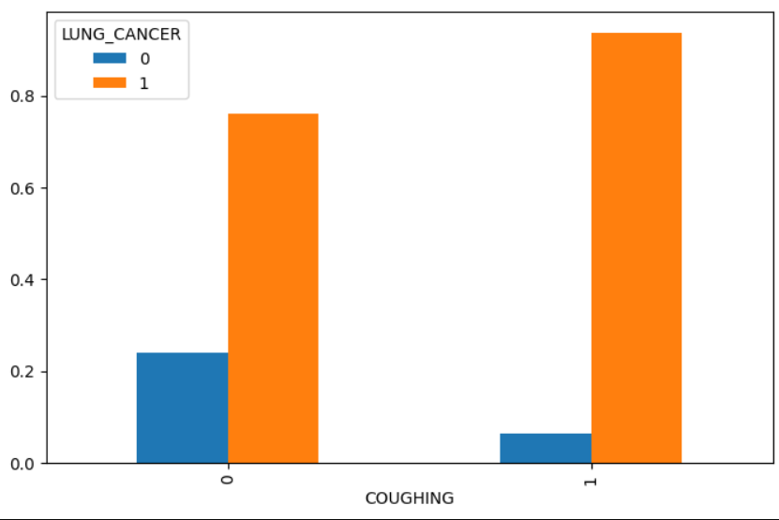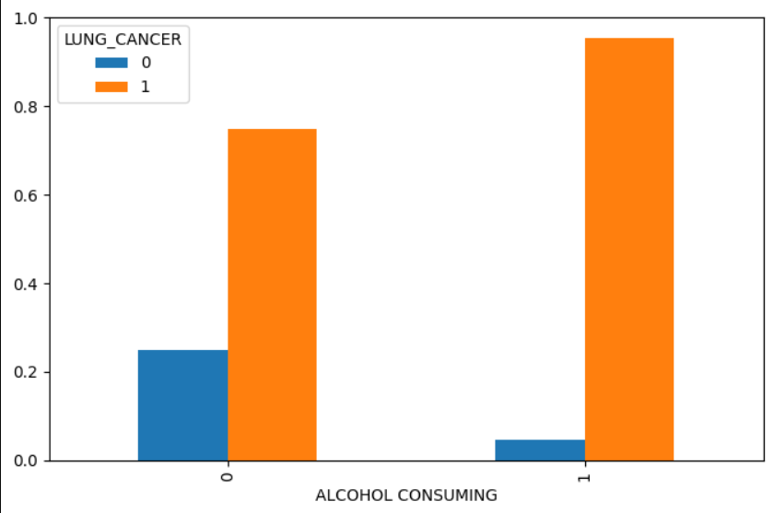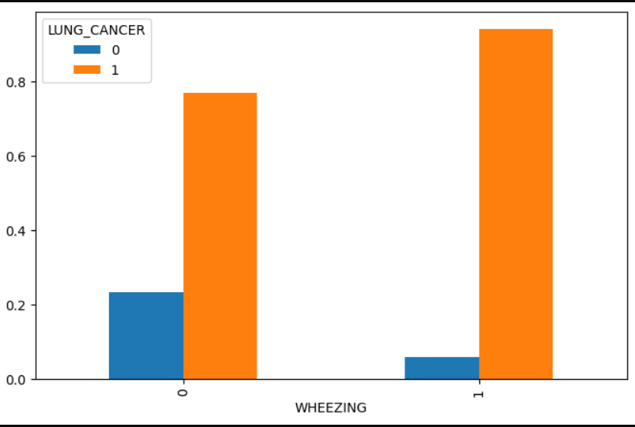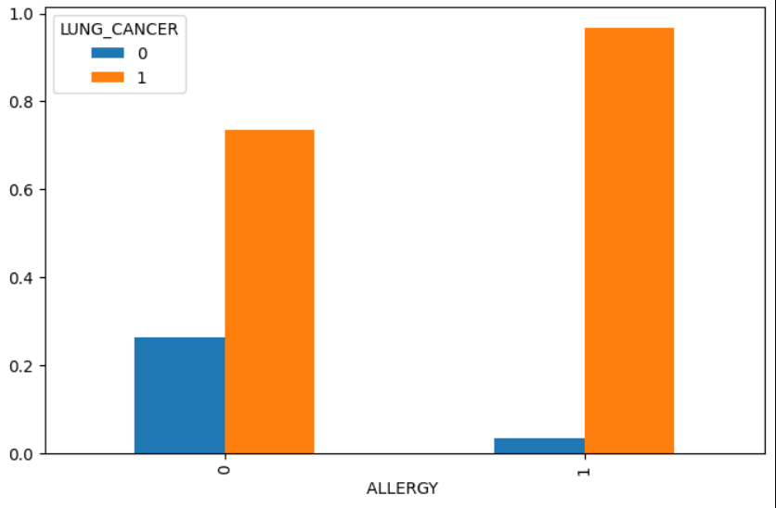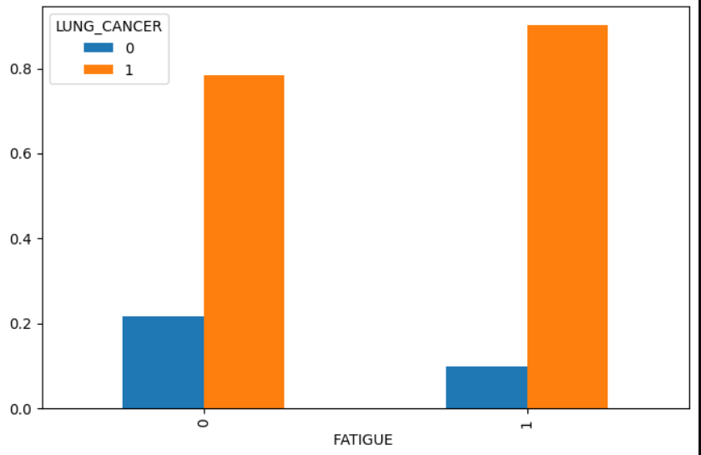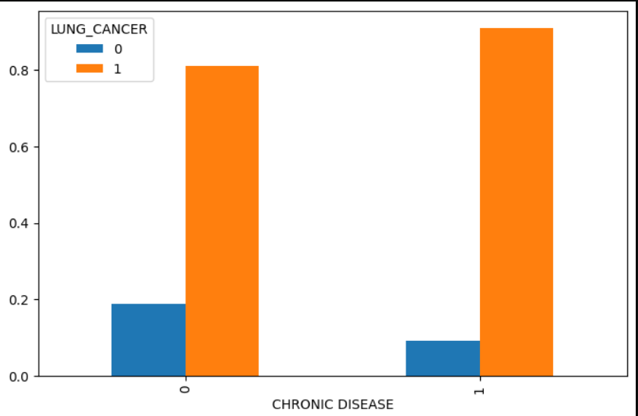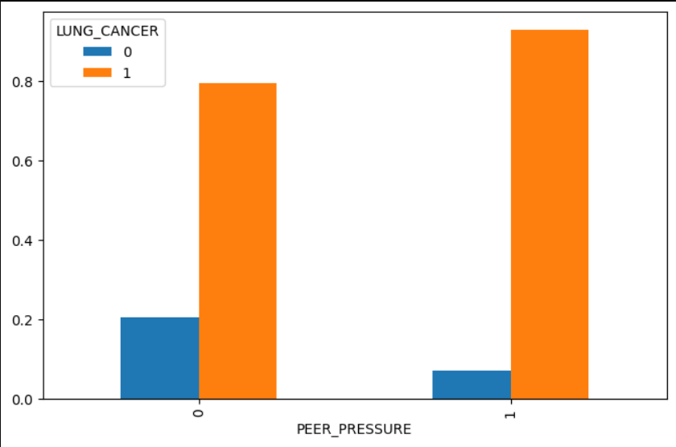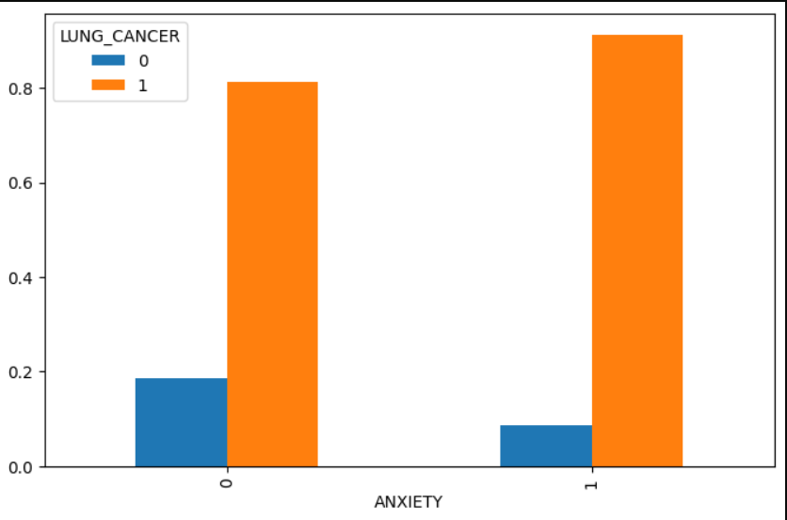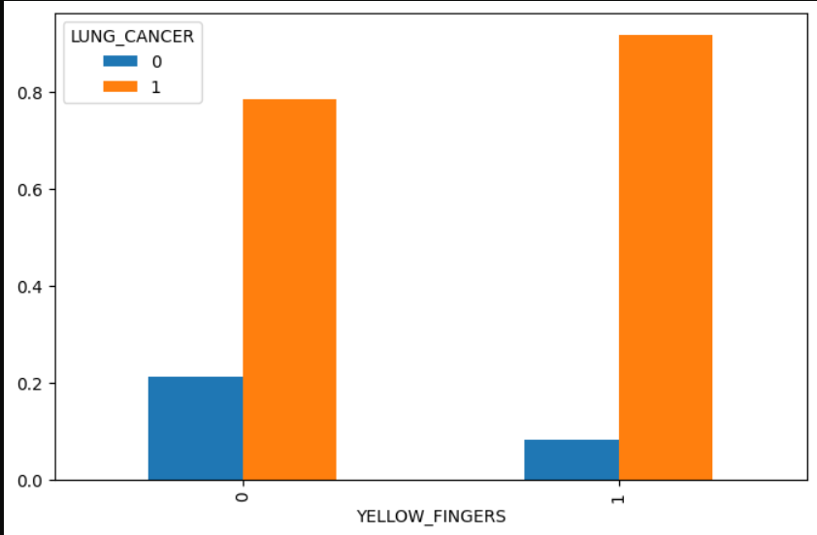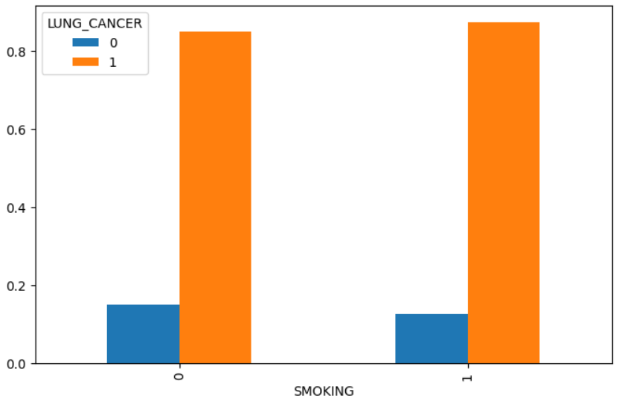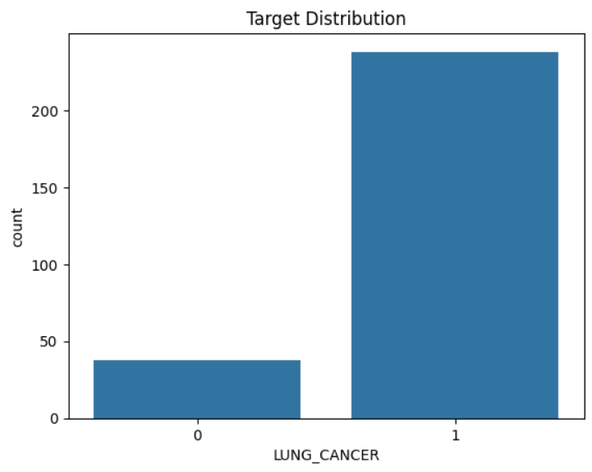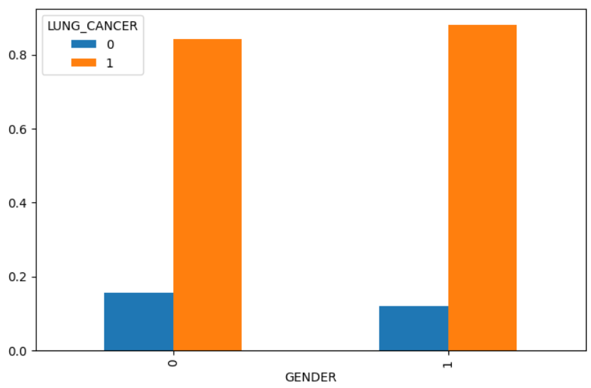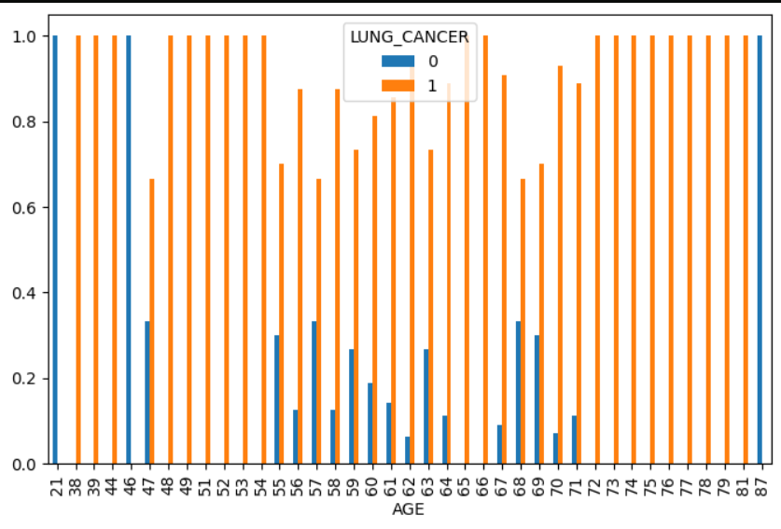

IX. RESULT AND DISCUSSION

* Positive Results:

1. High Accuracy: Studies report promising accuracy rates, with some models achieving over 90% accuracy in differentiating cancerous from benign lung nodules on CT scans.
2. Early Detection: ML models can potentially identify lung cancer at earlier stages when treatment is more effective, leading to better patient outcomes.
3. Data-driven Insights: Extracting features from medical data using ML can reveal previously unknown patterns or relationships, aiding in improved diagnosis and risk assessment.

* Discussion Points and Considerations:

1. Data Quality and Generalizability: Model performance heavily relies on the quality and comprehensiveness of training data. Biases or limitations in data can affect generalizability to real-world populations.
2. Overfitting and Explainability: Complex models can be overfit to training data, impacting performance on unseen data. Explainable AI (XAI) techniques are crucial to understand the model's reasoning and ensure trust in its predictions.

* Integration with Clinical Workflow: For successful adoption, seamless integration of ML models with existing healthcare workflows and electronic health records (EHR) systems is essential.
* Additionally, the discussion should delve into:

Comparison of Algorithms: Discuss the performance of different ML algorithms used for lung cancer prediction, highlighting their strengths and weaknesses in this context.

Clinical Validation: The importance of rigorous clinical trials to validate the model's effectiveness in real-world clinical settings cannot be overstated.

Ethical Considerations: Data privacy, potential bias in algorithms, and the role of human expertise in conjunction with ML models require careful consideration.

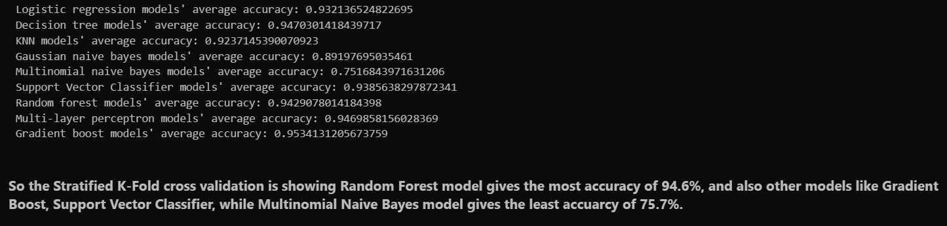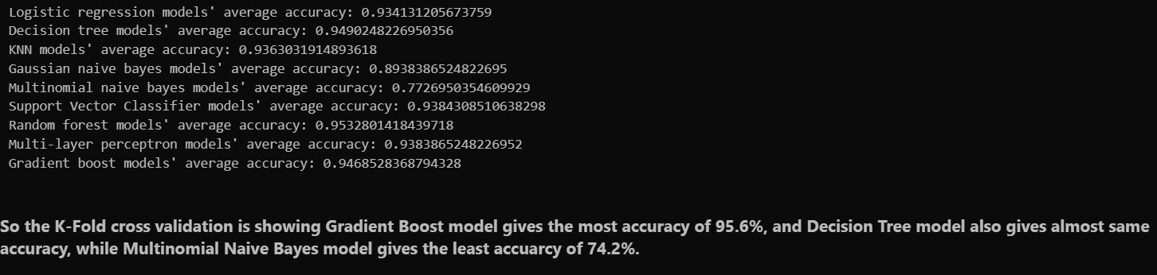

# X. CONCLUSION AND FUTURE WORK:

With the potential to enhance patient outcomes and early diagnosis, machine learning (ML) provides a promising method for predicting lung cancer. Research has demonstrated encouraging outcomes when applying different machine learning methods, especially when deep learning techniques and high-quality data are used to analyse medical pictures. Even while problems like interpretability and data imbalance still exist, these are being addressed by continuous study.

* Model Optimization: To increase accuracy, generalizability, and resilience to changes in data, current machine learning research might concentrate on refining already-existing models. Promising are ensemble approaches that combine many feature extraction and classification algorithms and methodologies.
* Explainable AI (XAI): Gaining the trust of medical practitioners and guaranteeing appropriate use in clinical settings requires developing ways to explain how ML models arrive at their predictions.   
  Clinical Workflow Integration: Healthcare providers' adoption of ML models will be aided by their seamless interaction with current electronic health record (EHR) systems and diagnostic tools.
* Data Standardization and Sharing: Inter-institutional cooperation and data sharing can result in the creation of more reliable and broadly applicable machine learning models. For data sharing to be effective, data formats and gathering techniques must be standardized.
* Clinical Trials and Validation: To confirm that machine learning models work as intended in actual clinical settings, strong clinical trials are essential. This will open the door for widespread clinical practice acceptance and regulatory approval.  
  Emphasis on Risk Stratification and Early Detection Treatment strategies may be optimized, and patient outcomes can be enhanced, by refining machine learning models for early lung cancer diagnosis and patient risk assessment.

Beyond Forecast:   
  
**Personalization**: By customizing risk assessment and screening methods based on unique patient features and risk variables, machine learning models can contribute to customized medicine.

**Drug Discovery and Treatment Optimization:** Large-scale datasets may be analysed using machine learning techniques to find possible drug targets or lung cancer patients' recommended treatment plans.

**XI. BUSINESS MODELS**

* Software as a Service (SaaS):

1. Target Market: Hospitals, radiology clinics, and healthcare providers offering lung cancer screening programs.
2. Value Proposition: SaaS platform integrating the ML model for automated lung cancer risk assessment from scans (X-ray, CT).
3. Revenue Model: Subscription fees based on usage (number of scans analysed), tiered pricing based on features offered (e.g., basic vs. advanced reporting).

* Cloud-based Risk Assessment Service:

1. Target Market: Insurance companies, health and wellness institutions.
2. Value Proposition: Web-based platform where individuals can upload medical history and imaging data (with privacy safeguards) for lung cancer risk assessment.
3. Revenue Model: Pay-per-use model for individual risk assessments, bulk discounts for insurance companies screening large populations.

* AI-powered Decision Support System:

1. Target Market: Hospitals, oncology clinics specializing in lung cancer diagnosis and treatment.
2. Value Proposition: Integrate the ML model within existing medical imaging analysis software to provide radiologists with a second opinion and risk stratification for lung nodules.
3. Revenue Model: One-time licensing fee for the software integration or a combination of license fee and recurring support charges.

* Combined Model with Telehealth Platform:

1. Target Market: General public for proactive health management.
2. Value Proposition: Develop a mobile app or telehealth platform where users answer questionnaires and potentially upload scans for preliminary lung cancer risk assessment by the ML model, followed by consultations with healthcare professionals if needed.
3. Revenue Model: Freemium model with free basic risk assessment and premium features like detailed reports and doctor consultations for a fee.

* Important Considerations:

1. Regulatory Compliance: Ensure the ML model and business practices adhere to data privacy regulations (HIPAA) and relevant medical device certifications.
2. Clinical Validation: Rigorous clinical trials are crucial to establish the model's accuracy and gain trust from healthcare providers.
3. Explainability and Transparency: Develop mechanisms to explain the ML model's reasoning behind its predictions for better adoption by medical professionals.
4. Success Factors:

* Accuracy and Interpretability: The ML model's ability to deliver reliable predictions with a clear understanding of its decision-making process is paramount.
* Integration with Existing Systems: Seamless integration with existing healthcare workflows and software is essential for user adoption.

1. Partnerships: Collaborations with hospitals, medical imaging companies, and healthcare providers can accelerate adoption and market reach.

XII.REFERENCES

**Research Papers:**

1."Early Lung Cancer Detection Using Deep Learning Based on Enhanced Image Reconstruction of Low-Dose Chest CT Scans" by Ardila, D., Kiraly, A. P., Bharadwaj, S., Choi, B., Reicher, J. J., Peng, L., Tse, D., Etemadi, M., Ye, W., Corrado, G., Naidich, D. P., Shetty, S., and End-to-End Lung Cancer Screening Consortium. This paper discusses a deep learning-based approach for early lung cancer detection using low-dose chest CT scans.

2."Deep Learning for Lung Cancer Prognosis Prediction: A Retrospective Multi-Cohort Radiomics Study" by Huang, Y., Liu, Z., He, L., Chen, X., Pan, D., Ma, Z., and Liang, C. This study explores the use of deep learning and radiomics features for predicting the prognosis of lung cancer patients.

3."Early Prediction of Lung Cancer Incidence Using Deep Learning" by Akkus, Z., Ali, I., Sedlář, J., Agrawal, J. P., Parashar, A., and Bhagwat, N. This paper presents a deep learning-based approach for early prediction of lung cancer incidence using chest CT images.

**4.Title:** "Deep Learning for Predicting Lung Cancer Incidence from CT Imaging Data”.

**Authors:** Ardila, Diego et al.

**Published in:** IEEE Transactions on Medical Imaging, vol. 38, no. 12, 2019, pp. 1344-1353.

**Abstract:** This paper presents a deep learning approach for predicting lung cancer incidence from computed tomography (CT) imaging data. They propose a novel deep learning architecture and demonstrate its performance on a large dataset of CT scans.

**5.Title:** "Lung cancer detection and classification with 3D convolutional neural networks"

**Authors:** Setio, Arnaud Arindra Adiyoso et al.

**Published in:** Proceedings of the IEEE conference on computer vision and pattern recognition, 2016, pp. 834-842.

**Abstract:** This paper proposes a 3D convolutional neural network (CNN) approach for lung cancer detection and classification using CT scans. They demonstrate the effectiveness of their method on a dataset of CT scans.

**6.Title:** "Prediction of lung cancer incidence on the low dose computed tomography arm of the National Lung Screening Trial: A dynamic Bayesian network”.

**Authors:** ten Haaf, Kevin et al.

**Published in:** PloS one, vol. 11, no. 12, 2016, e0163210.

**Abstract:** This study develops a dynamic Bayesian network model for predicting lung cancer incidence using data from the National Lung Screening Trial. They assess the performance of their model in predicting lung cancer incidence.

**7.Title:** "Predicting lung cancer incidence from computed tomography screening”.

**Authors:** Katki, Hormuzd A et al.

**Published in:** Journal of the National Cancer Institute, vol. 106, no. 11, 2014.

**Abstract:** This paper presents a risk prediction model for lung cancer incidence based on computed tomography (CT) screening data. They develop and validate their model using data from the National Lung Screening Trial.